**SECURED CAR PARKING SYSTEM**

A software Engineering project submitted

By

*Hossain, Shahadat (13-23733-1)*

*HUQ, NAZMUL (13-23991-2)*

*MIMUN BARID (14-27428-2)*

*KHONDOKER MD. HASAN (15-29388-1)*

Under the supervision of

*MOHAMMAD MAHMUDUL HASAN*

*Lecturer*

**Department of Computer Science**

**Faculty of Science & Information Technology**

**American International University – Bangladesh  
 Fall 16_17**

1. **PROBLEM DOMAIN**
   1. **Background to the Problem**

*A large number of peoples are come to “BC” Shopping mall every day. Some customer are complaining about a long line at parking area. Sometimes the line is too big that the main road traffics are hampered by this. Another problem is the entrance of every car is operated by analog system (giving a tag or, ticket). So, the car is not secured well in the parking area and some case it’s stolen. It is a burning issue now a days.*

*Long line of the parking are hampering the time of the customer. It’s hampered the reputation of “BC” Shopping mall. If “BC” Shopping mall can provide it computerized automatic entrance rather than the existing system. “BC” Shopping mall need well reputation, save the customer’s time and give a secured parking system.*

* 1. **Solution to the Problem**

For this problem “BC” Shopping mall need an automated system. Because a user or customer just enter this parking area by only one registration. Next time when the same customer came into the parking area he/she only need a password and an entrance password will provide to go out from the parking area. It is a secured and time consumed system which can solve both time complexity and security.

The main goal of this project is to consuming the time of the customer while entering the “BC” Shopping mall parking area and give the security of the vehicles. An automated system which can give an auto generated password, controlled by CCTV camera, Admin accessibility and restored the relevant data about the customer car and owner’s details in the database.

**SOLUTION DESCRIPTION**

* 1. **User Scenario**

|  |  |  |
| --- | --- | --- |
| **Sample use-case** | **Actor** | **Corresponding user scenario** |
| Customer entrance | Customer | Customer Enter the system with a password so that he/ she can recognised by system. If he/she was not registered, He/she should be registered by doing registration |
| Customer Exit | Customer | Customer exit the system by giving auto generated password so that no one can have that vehicles without the owner. |
| Admin Dashboard | Admin | Admin can see overall process so that he/she can monitoring the system. |

* 1. **UML**

**Class Diagram:**

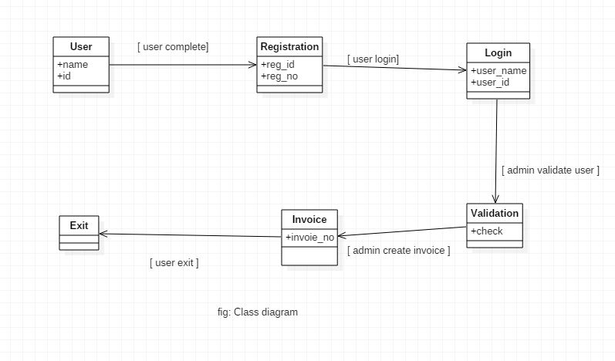

*Activity Diagram:*

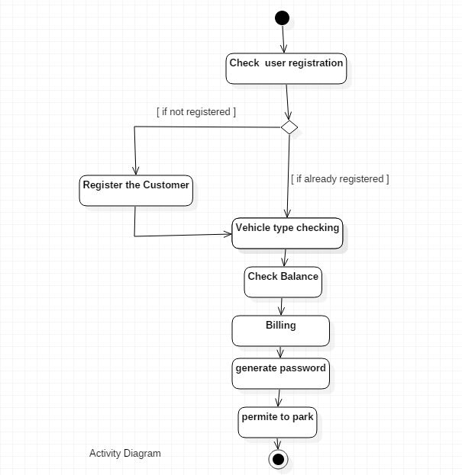

*Use Case Diagram:*

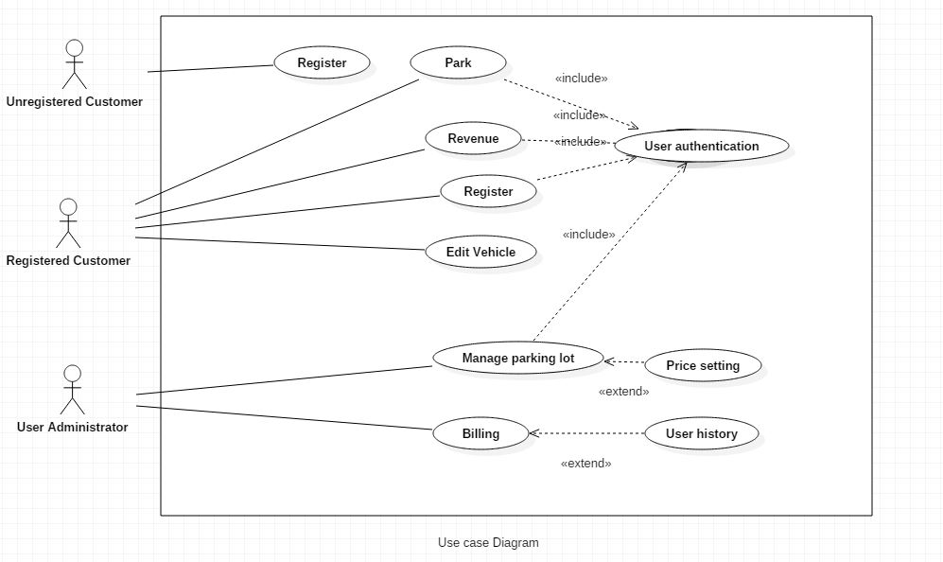

*ER Diagram:*

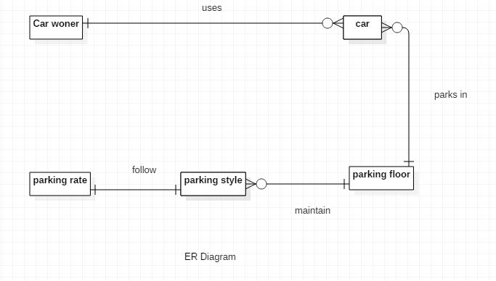

**Data Dictionary:**

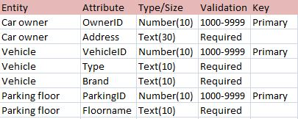

1. **SOFTWARE DEVELOPMENT LIFE CYCLE**
   1. **Solution Analysis**

To build this software first of all company need to have a practical experience of the scenario described by the client. After having the practical analysis of the system’s current position or current process of the parking area entrance and exit, the software Company decided to follow a Model to complete this project.

The current System has:

1. Data Entity in the entrance.
2. Giving a slip taken money.
3. The vehicles are not arranged.
4. Losing the security for not to have any pass code accept registration number of the car. If anyone duplicated the slip, can take the car and go out.
5. Customer having difficulty at entrance entry and at exit collecting the slip.

By seeing current process the Software Company decided that Agile method is the best method to follow for completing the Project. From Agile method The Company will follow the Extreme Programming (XP)

* 1. **Arguments for Choice of method(s)**

*XP method has values which made the project easier for both customer and Seller (Software Company).The reason Company chose this given bellow:*

***1. Communication:*** *XP has a culture of oral communication and its practices are designed to encourage interaction.   
“Problems with projects can invariably be traced back to somebody not talking to   
 somebody else about something important.”*

***2. Simplicity:*** *Design the simplest product that meets the customer’s needs. An important aspect of the value is to only design and code what is in the current requirements rather than to anticipate and plan for unstated requirements.*

***3. Feedback:*** *The development team obtains feedback from the customers at the end of each iteration and external release. This feedback drives the next iteration.*

***4. Courage****: Allow the team to have courage in its actions and decision making. For example, the development team might have the courage to resist pressure to make unrealistic commitments.*

***5. Respect:*** *Team members need to care about each other and about the project.*

***How this method is helping our project:***

*This method follows some iteration and each iteration there is specific testing will be occurred. So it’s important to find out the problem while developing. Communication with the client is the most important things. So agile method creates this type of opportunity to interact with the client and the buyer.*

1. **INDUSTRIAL ATTACHMENT**
   1. **Company Background**

*A Software company in Mohakhali DOHS named Vencerlab which is a startup software company. The size of the company wasn’t too big but service of the company was good. The Company is following agile method to do any project most of the time they are using XP Model. They are working on Web development, ERP, Office management System etc.*

* 1. **Company Practice**

*The Company is following Agile method to do any project most of the time they are using XP Model. The company working on a Govt. project and following agile method to complete this project*

**Improvement of the Practice**

*They are following Agile methods specially Scrum, XP in their Company. In some portion they are mixing up among methods. It will be better to follow one specific methods and practice same methods. We suggest them about the Agile methods. We describe whole method procedure of DSDM and FDD also and cross match the existing if there is any mismatch among the main methods and methods the company are following. We asked some question to the project manager,*

1. *Is a project going through any methods?*

*Ans: “Yes, We are following Scrum and XP to complete a project.”*

*2. Are those practice helpful or not?*

*Ans: “Yes, According to this region usually every software companies are following this method.”*

*3. What measures are taken to continue this practice?*

*Ans: “We hired experienced agile personnel to follow this practice. Actually we are following several methods under Agile Software development. Like XP, Scrum,…etc. There are mixing up methods we are following according to the situation. Sometimes it is varied client to client.”*

*4. Why not DSDM and FDD or others?*

*Ans: “Scrum and XP are likely to similar to each other and ease to use in this region. As we are handling local client we are using this methods. In Scrum and Xp there are several iteration which can help to have the feedback from the client instantly. As we know local clients are likely to have lots of changes during the development. So we should have the feedback from the client at each iteration. That’s why we are following this methods.”*

1. **ACKNOWLEDGEMENT**

*References:*

1. [*https://www.quora.com/*](https://www.quora.com/)*.*
2. [*https://www.ieee.org/*](https://www.ieee.org/index.html) *.*
3. *Course Slide provided by Course Lecturer: MOHAMMAD MAHMUDUL HASAN*
4. *For Software Company Information: Mr. Rakib Al Hasan, Project Manager, Vencerlab. He supported us to build up the documentation on the Software Company Current practice.*